**ScienceQtech Employee Performance Mapping.**

PROJECT REPORT SUBMITTED BY :DINKY

1. Create a database named employee, then import data_science_team.csv , proj_table.csv and emp_record_table.csv into the employee database from the given resources.

**Output:**

**I create a database named as scienceqtech**

CREATE DATABASE scienceqtech;

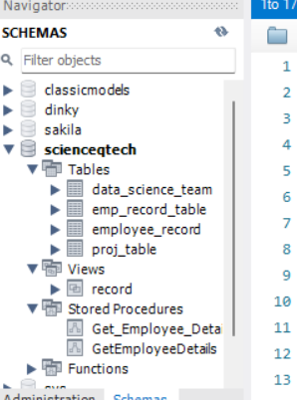

2.Create an ER diagram for the given **project** and the **employee** databases.

**Output:**

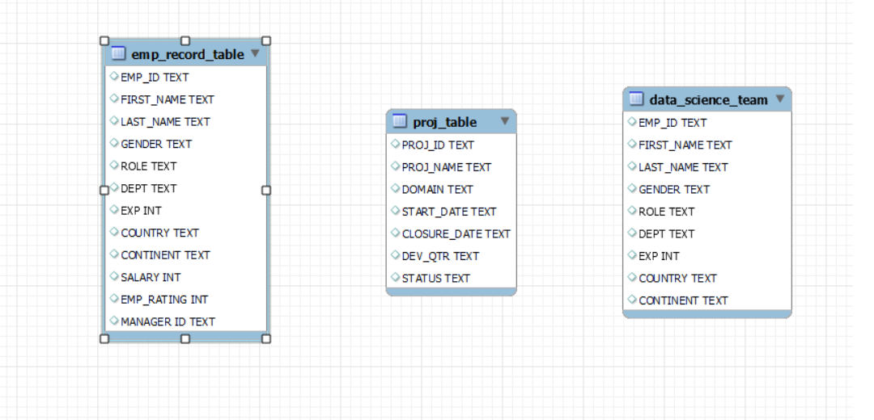

1. Write a query to fetch EMP_ID, FIRST_NAME, LAST_NAME, GENDER, and DEPARTMENT from the employee record table, and make a list of employees and details of their department.

**SQL code:**

SELECT EMP_ID,FIRST_NAME,LAST_NAME,GENDER,DEPT FROM scienceqtech.emp_record_table;

**Output:**

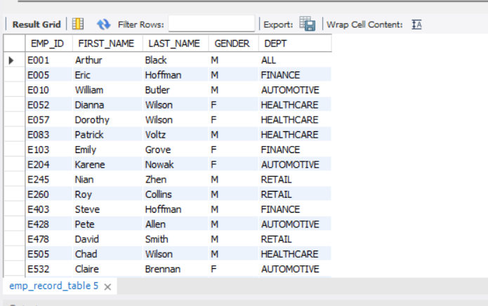

1. Write a query to fetch EMP_ID, FIRST_NAME, LAST_NAME, GENDER, DEPARTMENT, and EMP_RATING if the EMP_RATING is:

* less than two
* greater than four
* between two and four

**SQL code:**

SELECT EMP_ID,FIRST_NAME,LAST_NAME,GENDER,DEPT,EMP_RATING FROM scienceqtech.emp_record_table;

**Output:**

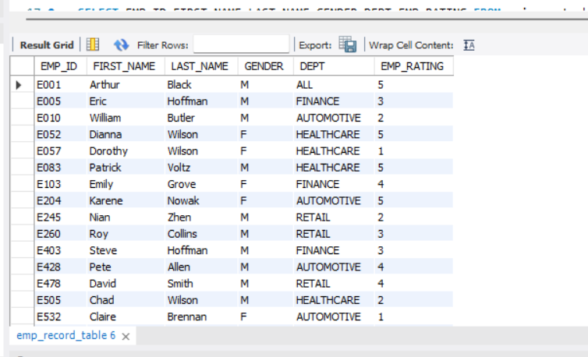

1)SELECT EMP_ID,FIRST_NAME,LAST_NAME,GENDER,DEPT,EMP_RATING FROM scienceqtech.emp_record_table where EMP_RATING>4 ;

**Output:**

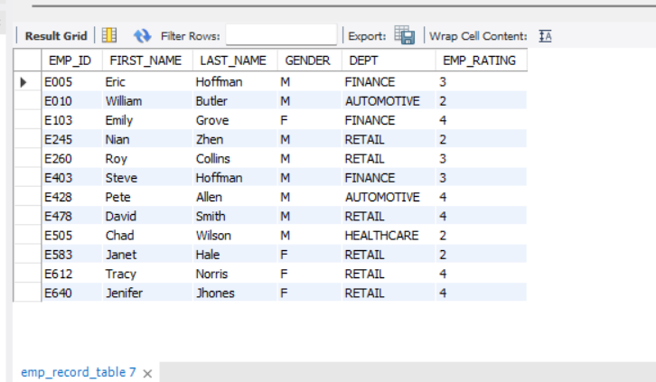

2)SELECT EMP_ID,FIRST_NAME,LAST_NAME,GENDER,DEPT,EMP_RATING FROM scienceqtech.emp_record_table where EMP_RATING between 2 AND 4 ;

**Output:**

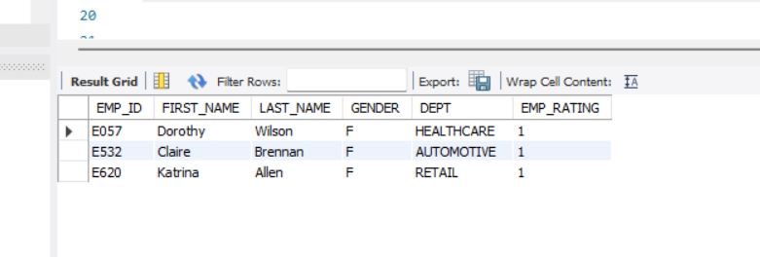

3)SELECT EMP_ID,FIRST_NAME,LAST_NAME,GENDER,DEPT,EMP_RATING FROM scienceqtech.emp_record_table where EMP_RATING < 2 ;

**Output:**

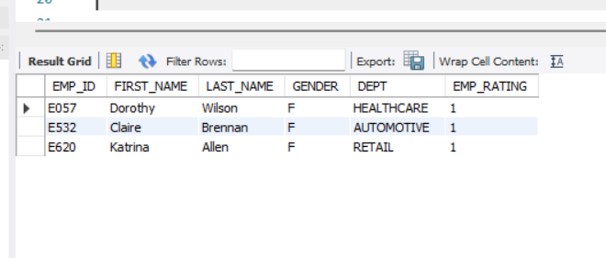

1. Write a query to concatenate the FIRST_NAME and the LAST_NAME of employees in the Finance department from the employee table and then give the resultant column alias as NAME.

**SQL code:**

SELECT concat(FIRST_NAME," " ,LAST_NAME) AS FULL_NAME FROM scienceqtech.emp_record_table where DEPT="FINANCE" ;

**Output:**

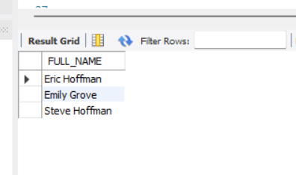

1. Write a query to list only those employees who have someone reporting to them. Also, show the number of reporters (including the President).

**SQL code:**

SELECT m.EMP_ID, m.FIRST_NAME, m.LAST_NAME, m.ROLE,m.EXP, m.DEPT, COUNT(e.EMP_ID) as "EMP_COUNT"

FROM scienceqtech.emp_record_table m

INNER JOIN scienceqtech.emp_record_table e

ON m.EMP_ID = e.MANAGER_ID

AND e.EMP_ID != e.MANAGER_ID

WHERE m.ROLE IN ("MANAGER", "PRESIDENT", "CEO")

GROUP BY m.EMP_ID, m.FIRST_NAME, m.LAST_NAME, m.ROLE, m.EXP, m.DEPT

ORDER BY m.EMP_ID;

**Output:**

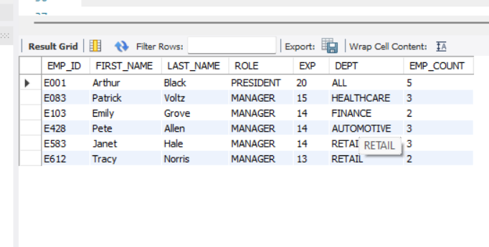

1. Write a query to list down all the employees from the healthcare and finance department using union. Take data from the employee record table.

**SQL code:**

SELECT EMP_ID,FIRST_NAME,DEPT FROM emp_record_table WHERE DEPT="HEALTHCARE"

UNION

SELECT EMP_ID,FIRST_NAME,DEPT FROM emp_record_table WHERE DEPT="FINANCE";

**Output:**

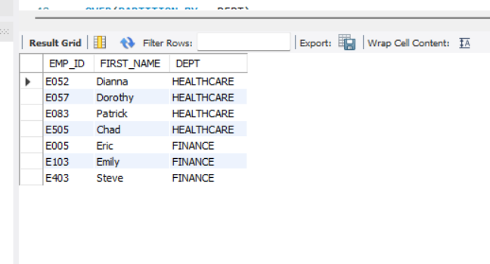

1. Write a query to list down employee details such as EMP_ID, FIRST_NAME, LAST_NAME, ROLE, DEPARTMENT, and EMP_RATING grouped by dept. Also include the respective employee rating along with the max emp rating for the department.

**SQL code:**

SELECT m.EMP_ID,m.FIRST_NAME,m.LAST_NAME,m.ROLE,m.DEPT,m.EMP_RATING,MAX(m.EMP_RATING)

OVER(PARTITION BY m.DEPT)

AS "MAX_DEPT_RATING"

FROM emp_record_table m

order by EMP_RATING;

**Output:**

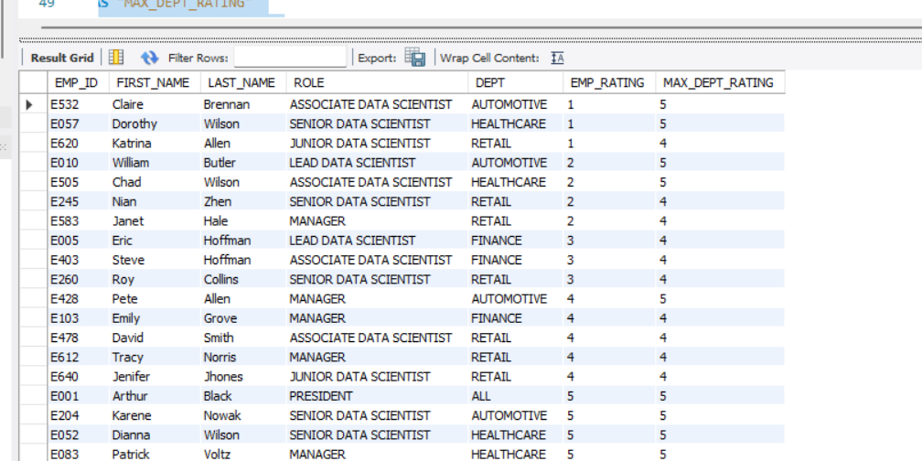

1. Write a query to calculate the minimum and the maximum salary of the employees in each role. Take data from the employee record table.

**SQL code:**

SELECT DISTINCT(ROLE), MAX(SALARY)

OVER (PARTITION BY ROLE) MAX_SALARY, MIN(SALARY)

OVER (PARTITION BY ROLE) MIN_SALARY

FROM scienceqtech.emp_record_table;

**Output:**

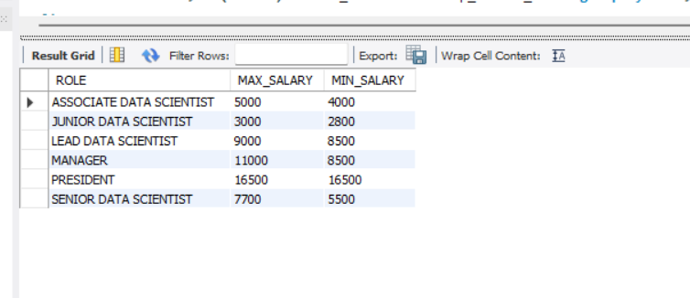

1. Write a query to assign ranks to each employee based on their experience. Take data from the employee record table.

**SQL code:**

SELECT FIRST_NAME,LAST_NAME, EXP,RANK() over(order by EXP DESC) AS RNK ,DENSE_RANK() OVER (ORDER BY EXP) AS DN_RANK FROM emp_record_table ;

**Output:**

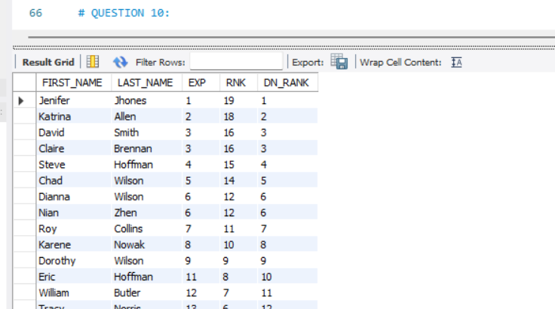

1. Write a query to create a view that displays employees in various countries whose salary is more than six thousand. Take data from the employee record table.

**SQL code:**

CREATE VIEW RECORD1 AS

SELECT EMP_ID,FIRST_NAME,LAST_NAME,COUNTRY,SALARY FROM scienceqtech.emp_record_table WHERE SALARY>6000;

select * FROM RECORD1;

**Output:**

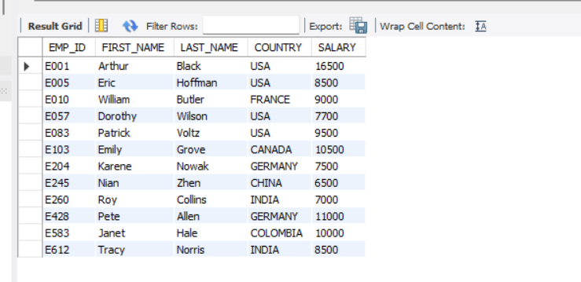

1. Write a nested query to find employees with experience of more than ten years. Take data from the employee record table.

**SQL code:**

SELECT EMP_ID,FIRST_NAME,LAST_NAME,GENDER,DEPT,EXP FROM emp_record_table

WHERE EMP_ID IN (SELECT MANAGER_ID FROM emp_record_table) ;

**Output:**

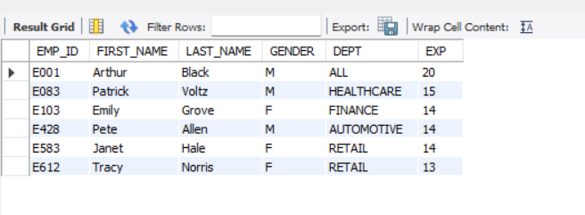

1. Write a query to create a stored procedure to retrieve the details of the employees whose experience is more than three years. Take data from the employee record table.

**SQL code:**

DELIMITER //

CREATE PROCEDURE Get_Employee_Details1()

BEGIN

SELECT EMP_ID,FIRST_NAME,LAST_NAME,SALARY,EXP FROM emp_record_table

WHERE EXP >3;

END //

CALL Get_Employee_Details1();

**Output:**

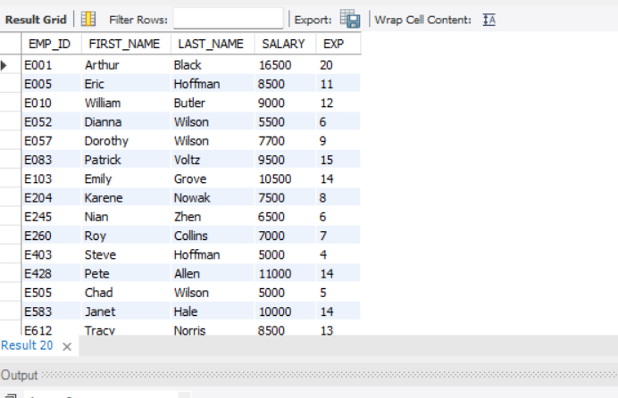

1. Write a query using stored functions in the project table to check whether the job profile assigned to each employee in the data science team matches the organization’s set standard.

The standard being:

For an employee with experience less than or equal to 2 years assign 'JUNIOR DATA SCIENTIST',

For an employee with the experience of 2 to 5 years assign 'ASSOCIATE DATA SCIENTIST',

For an employee with the experience of 5 to 10 years assign 'SENIOR DATA SCIENTIST',

For an employee with the experience of 10 to 12 years assign 'LEAD DATA SCIENTIST',

For an employee with the experience of 12 to 16 years assign 'MANAGER'.

**SQL code:**

DELIMITER //

CREATE FUNCTION JOB_PROFILE

( EXP int)

RETURNS VARCHAR (50)

DETERMINISTIC

BEGIN

DECLARE JOB_PROFILE VARCHAR (50);

IF EXP > 12 AND 16 THEN

SET JOB_PROFILE="MANAGER";

ELSEIF EXP > 10 AND 12 THEN

SET JOB_PROFILE="LEAD DATA SCIENTIST";

ELSEIF EXP > 5 AND 10 THEN

SET JOB_PROFILE="SENIOR DATA SCIENTIST";

ELSEIF EXP > 2 AND 5 THEN

SET JOB_PROFILE="ASSOCIATE DATA SCIENTIST";

ELSEIF EXP<=2 THEN

SET JOB_PROFILE="JUNIOR DATA SCIENTIST";

END IF;

RETURN (JOB_PROFILE);

END //

SELECT FIRST_NAME, LAST_NAME, DEPT,EXP,JOB_PROFILE(EXP) FROM data_science_team;

**Output:**

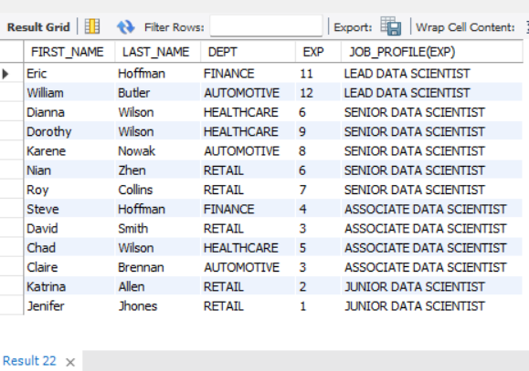

1. Create an index to improve the cost and performance of the query to find the employee whose FIRST_NAME is ‘Eric’ in the employee table after checking the execution plan.

**SQL code:**

SELECT * FROM scienceqtech.emp_record_table

WHERE FIRST_NAME='Eric';

**Output:**

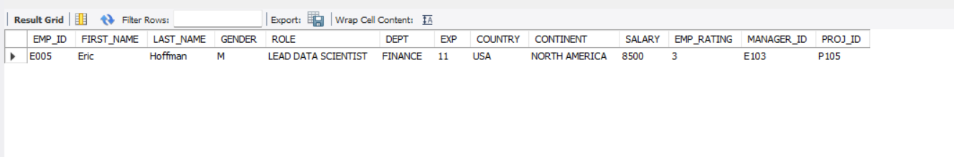

**SQL code:**

CREATE INDEX RAM ON scienceqtech.emp_record_table(FIRST_NAME(40));

SELECT * FROM emp_record_table WHERE FIRST_NAME="ERIC";

**Output:**



1. Write a query to calculate the bonus for all the employees, based on their ratings and salaries (Use the formula: 5% of salary * employee rating).

**SQL code:**

SELECT EMP_ID, FIRST_NAME, LAST_NAME, ROLE, SALARY, EMP_RATING, (SALARY/20)*EMP_RATING AS BONUS

FROM scienceqtech.emp_record_table;

**Output:**

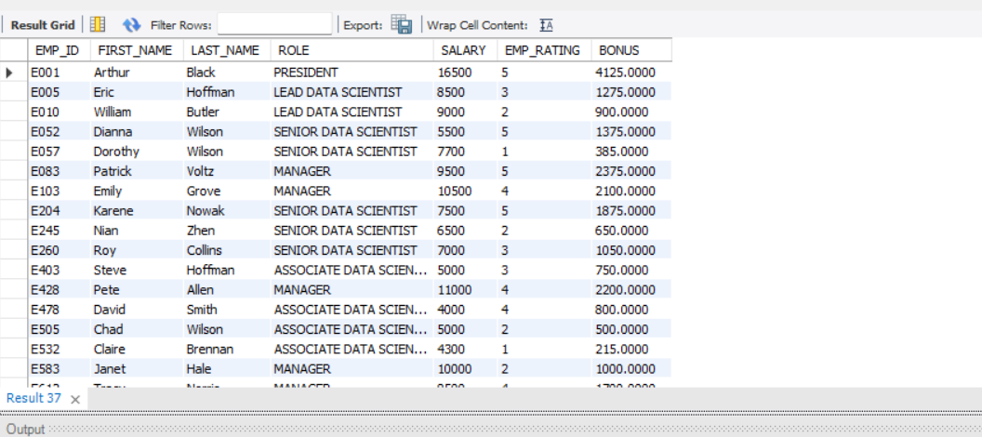

1. Write a query to calculate the average salary distribution based on the continent and country. Take data from the employee record table.

**SQL code:**

SELECT CONTINENT, COUNTRY, AVG(SALARY) as AVERAGE_SALARY

FROM scienceqtech.emp_record_table

GROUP BY CONTINENT, COUNTRY WITH ROLLUP;

**Output:**

